Static Design for car Control System

**MCAL**

**ECUAL**

**Microcontroller**

**APP**

**TIMER**

**PWM**

**DIO**

**MOTOR**

**Buttons**

**APP**

MCAL APIs

* DIO APIs

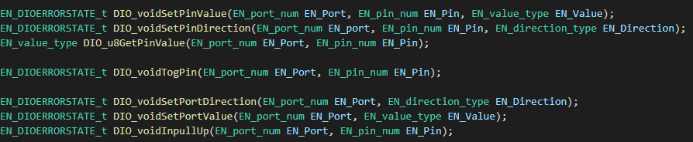

* TIMER APIs

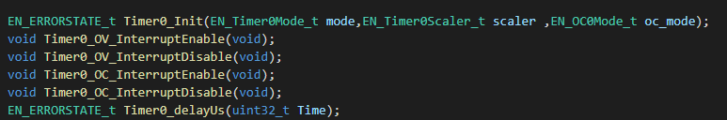

* PWM APIs

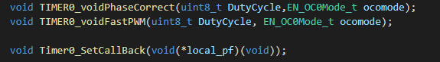

ECUAL APIs

* Buttons APIs



* MOTOR APIs

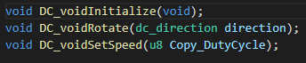

APP APIs

